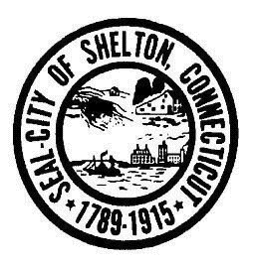City of Shelton
Parks & Recreation Department
41 Church Street, Shelton, CT 06484-0668
203-925-8422
Info/Cancellation 203-331-4120
www.cityofshelton.org

ADVERTISING SIGNS

on the Huntington Green

- Advertising may be done by
  - Local non-profit groups
  - City groups or organizations
  - Local churches

- Any group wishing to advertise must make a written request to the Parks and Recreation Department.

- Signs may not be displayed more than 2 weeks prior to the event and must be removed no more than 2 days after the event.

- They must be located in the corner of the Green near the fountain.

- No sign may be nailed into any trees.

- No sign may be larger than 16 sq. feet (4′ x 4′) per Planning and Zoning.
Special requests on size will be considered.

- No more than 5 advertisements may be present at one time.

- Political advertising is not allowed.

- The Parks and Recreation Commission or it’s agents has the right to refuse signs or advertisements it deems inappropriate.

- Anyone not following the above policy will have their sign removed by the Parks & Recreation Department.

Group: ______________________________ Type of Event: _______________________

Date of Event: ________________________ Display Dates: _______________________

I agree that the sign will be removed within 24 hours after the event.

____________________________________
Name

____________________________________

Phone #

